Day1:

**1.1**

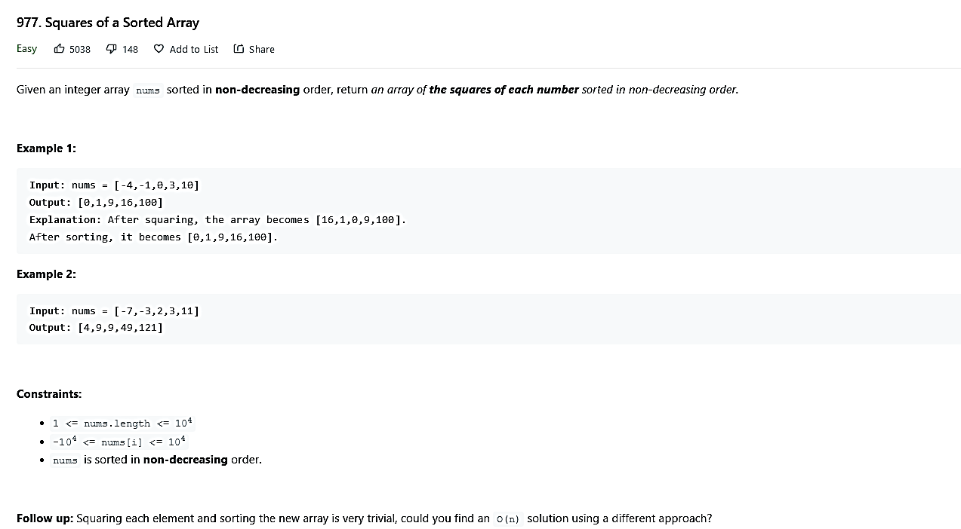

O(N) time code:

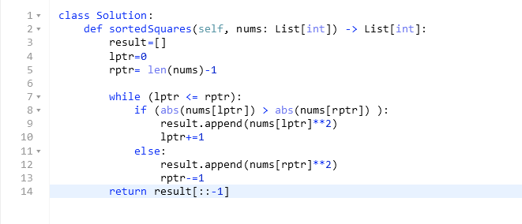

1.2

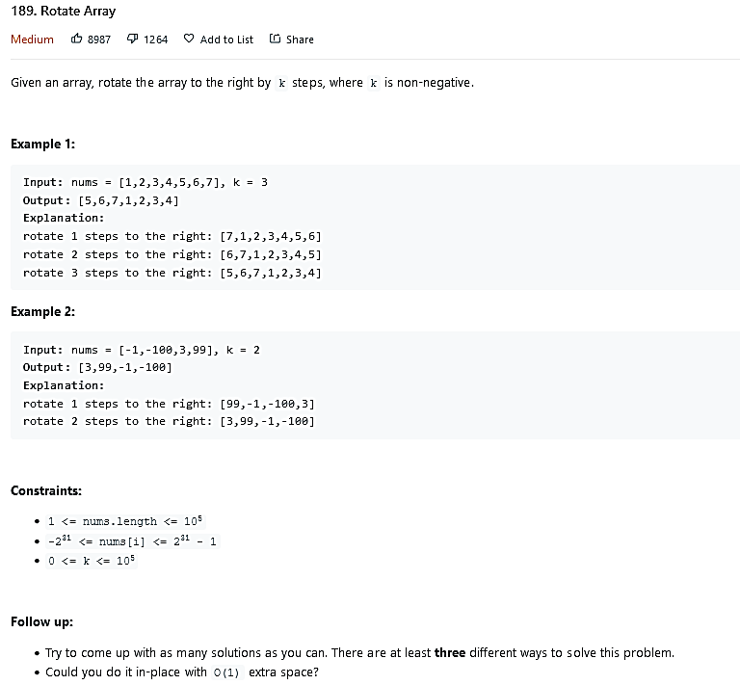

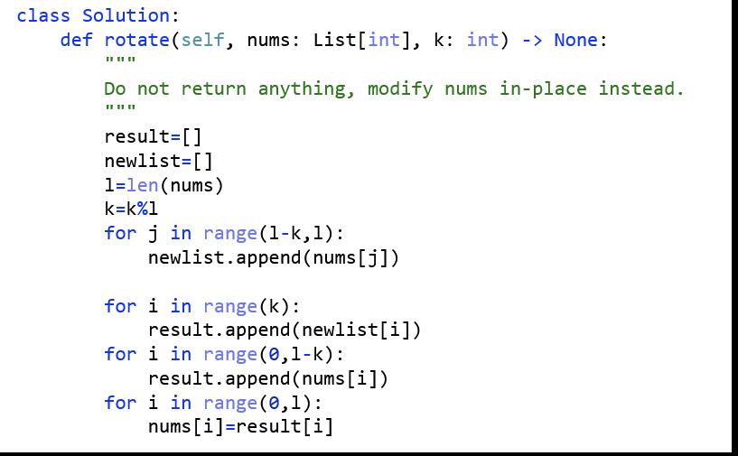

**Remember k=k%L it will be useful when k>L example [2,5] and k = 6**

Alternate solution in O(1) space complexity.

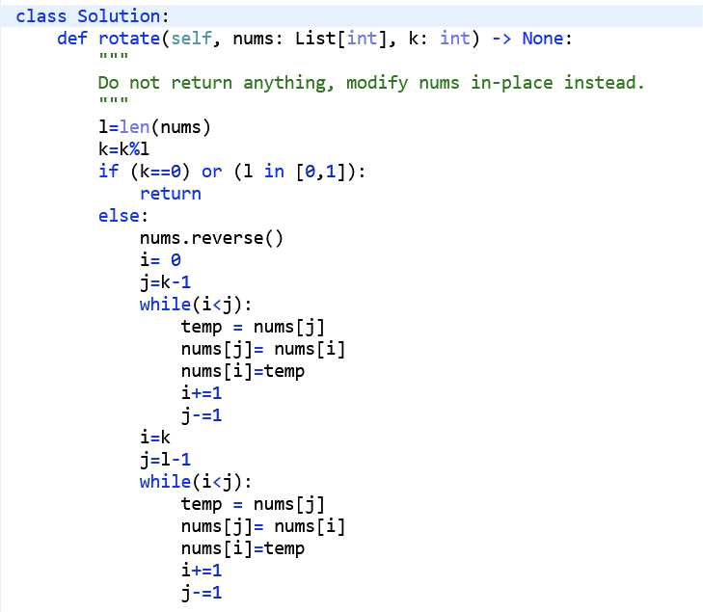

**1.4**

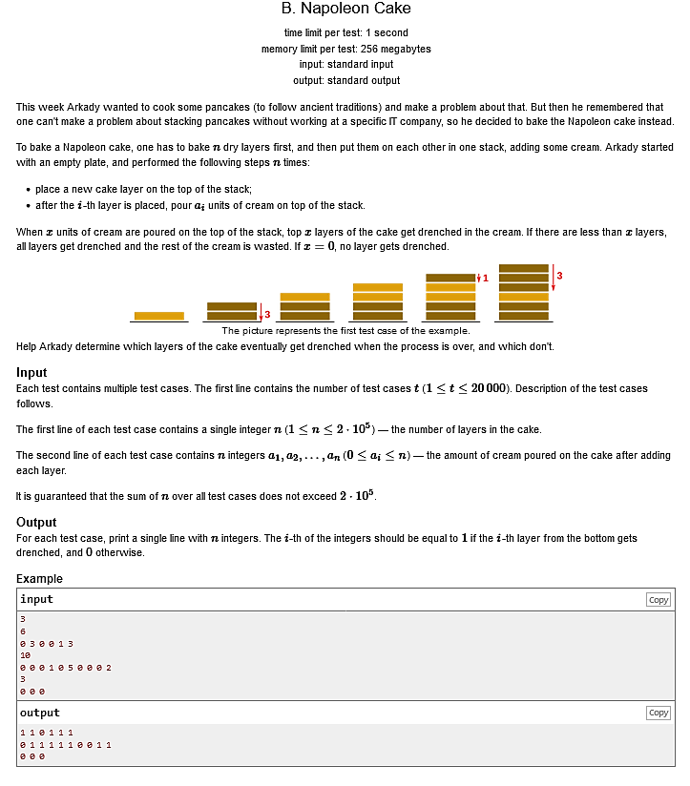

**Original solution:**

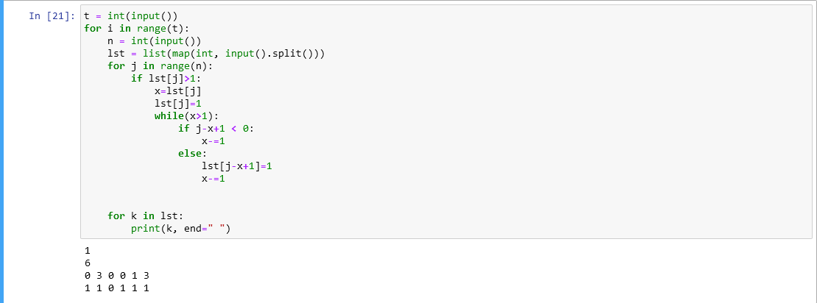

Gave time limit exceeded error (TLE) cuz have to traverse array multiple times. O(n^2)

**Better solution:**

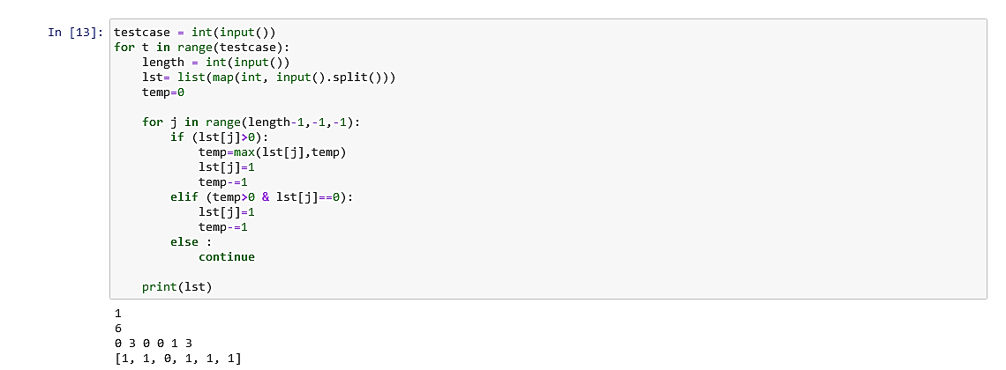

Will only scan array once by keeping temp variable. O(n)

**1.5**

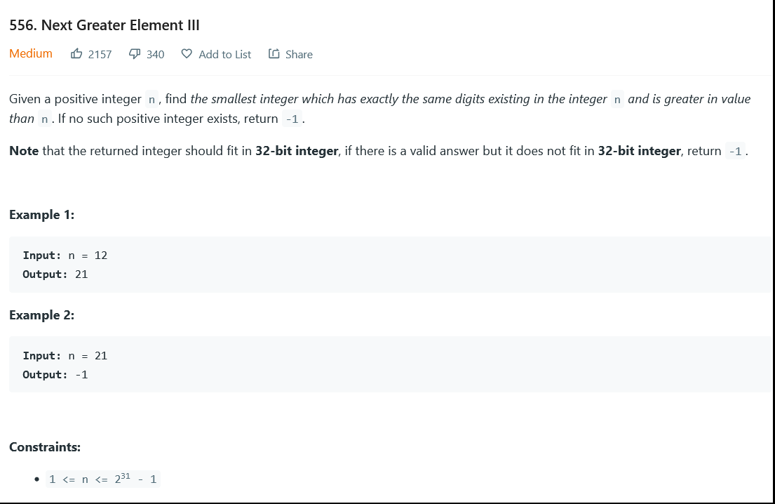

Ref:- <https://www.youtube.com/watch?v=eAfJJyaAmes>

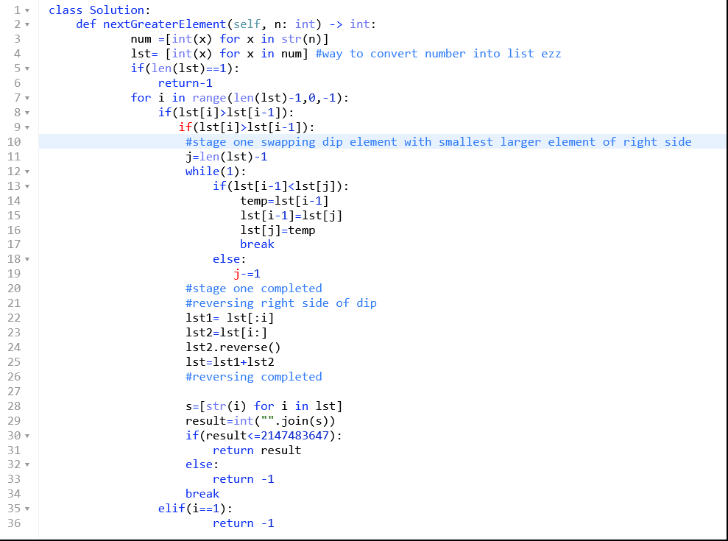

**1.6**

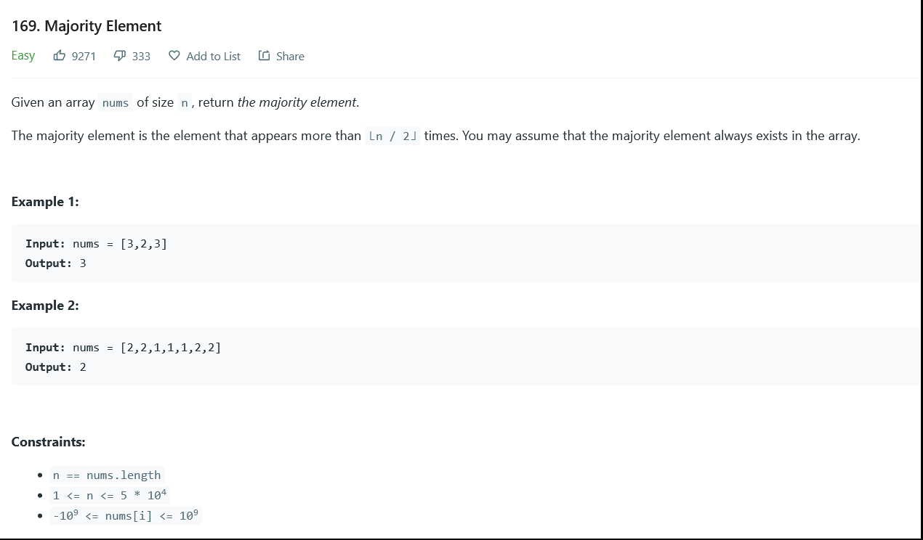

Easy but not efficient solution:

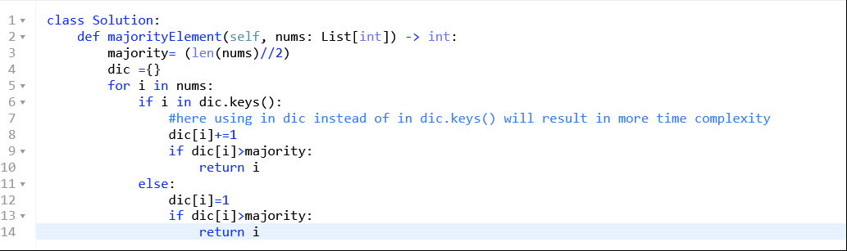

Easy and efficient solution:

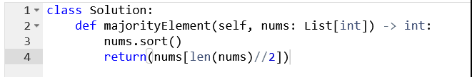

**Space O(1) solution**

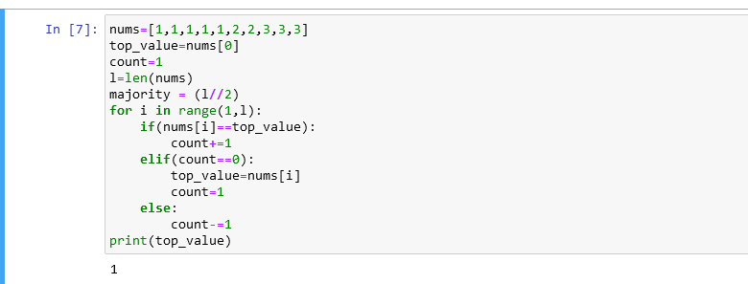

**1.7**

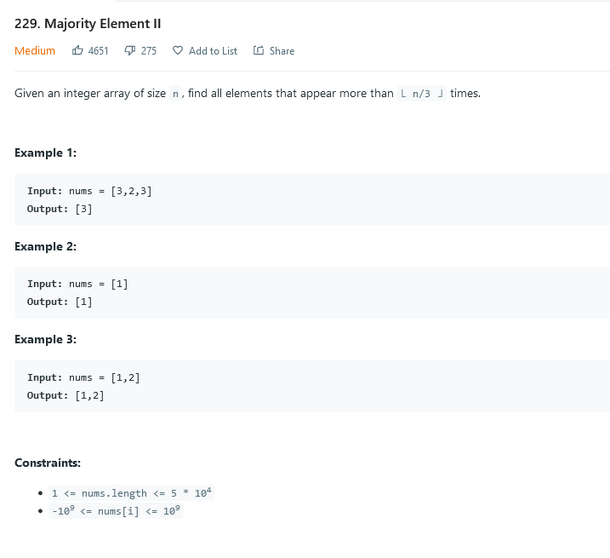

Solution: time O(n) and space O(1)

